**1**

**Template**

## Define your problem statement

**Before you collaborate**

A little bit of preparation goes a long way with this session. Here’s what you need to do to get going.

**10-15 minutes**

#### What problem are you trying to solve? Frame your problem as a How Might We statement. This will be the focus of your brainstorm.

**15 minutes**

**2**

## Brainstorm

#### Write down any idea that comes to mind that address your problem statement.

**10 minutes**

**3**

## Group ideas

#### Take turns sharing your ideas while clustering similar or related notes as you go. In the last 10 minutes, give each cluster a sentence-like label. If a cluster is bigger than six sticky notes, try and see if you and break it up into smaller sub-groups.

##### 20 minutes

**4**

## Prioritize

Your team should all be on the same page about what's important moving forward.Place your ideas on this grid to determine which ideas are important and which are feasible

##### 25 minutes

**Brainstorm**

**& idea prioritization**

**Ashwin.M**

**A Team gathering**

Define who should participate in the session and send an invite. Share relevant information or pre-work ahead.

**B Set the goal**

Think about the problem you'll be focusing on solving in the brainstorming session.

News Tracker Application is important nowadays because everyone are living a fast paced life where they no time to know about things happening around them.

Application is defined as a form to filled out , most often for a job or acceptance into an organization

# 

**C Learn how to use the facilitation tools**

Use the Facilitation Superpowers to run a happy and productive session.

**QUESTION**

News Tracker Application Category: Cloud app Development

All of our best apps roundups are written by humans who've spent much of their careers using, testing and writing about software

## Bhuvaneshwaran.S

In a web application project, source code is compiled into an assembly language, and that is what has to be on the web server.

Customization. Everyone reads the news in a different way, so

there needs to be many features available

for personalization.

Each app organizes its content differently, but I wanted to see some sort of category-based organization, whether that was tabs, side panels, grouped content, or anything else.

**Product Features**

At this digital era, people are captivated by smartphones or other mobile devices. people want all necessary info to be found at their fingertips.

**10 minutes** to prepare

**1 hour - 2hours** to collaborate

**2-8 people** recommended

Implementing web application

A hand held device

Revenue production by a new channel.

## Ragul Rathna.T

**Intererning more?**

[**Open the website**](https://www.facebook.com/business/m/thinkkit/?ref-northstar)

[Created in partnership with](https://about.facebook.com/)

Building high- end news apps can be time consuming and expensive.

Search and filter. Sometimes you're looking for a specific news topic, so I made sure search and filter capabilities allowed you to do that

**Mohan kumar.K**

News application development has come a long way in a very short time.

**Importance**

The news needed to be presented well and organized intuitively on a custom feed.

If each if these tasks could get done without any difficulty or cost, which would have the most positive impact?

News apps don’t serve the story for its own sake – they serve the user.

Developers in the newsroom are like water in the desert: highly sought after and in short supply.

A news application is a big interactive database that tells a news story. Think of it like you would any other piece of journalism.

Deployment of app in IBM cloud

Setting up application environment

Easy navigation

Here comes the arrival of the online magazines that are a popular and credible source of entertainment meeting user's requirements.

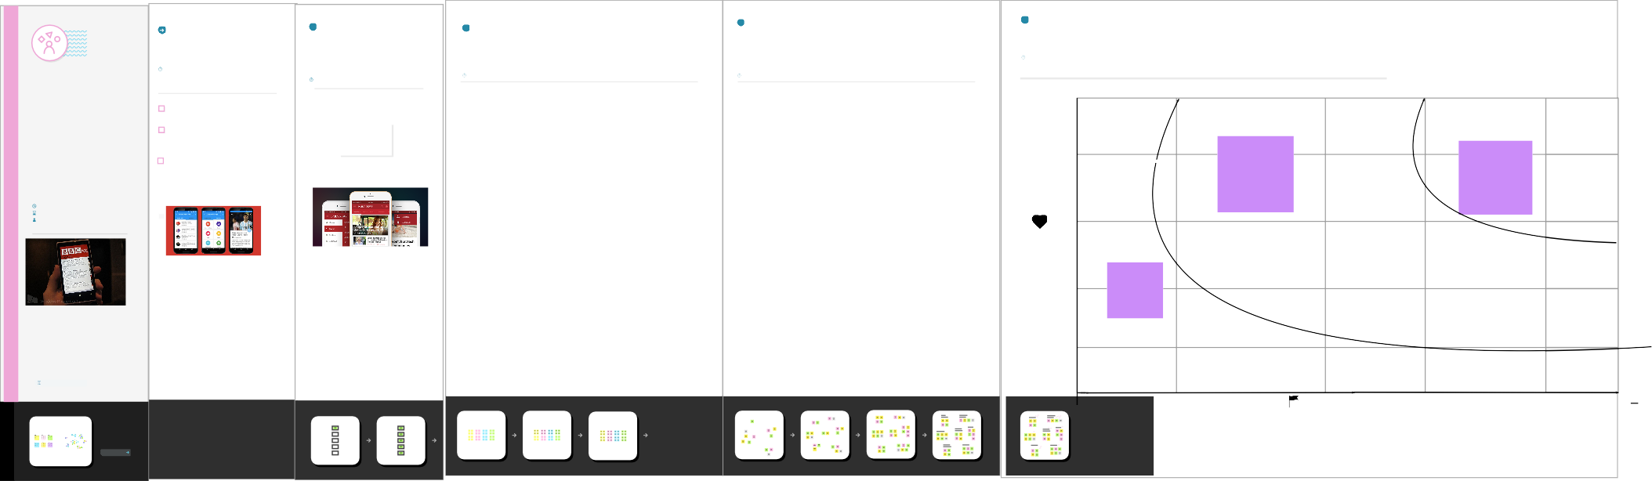

[**Share template feedback**](https://muralco.typeform.com/to/CiqaHVat?typeform-source=app.mural.co)

**Feasibility**

**Need some inspiration?**

See a finished version of this template to kickstart your work.

[**Open example**](https://app.mural.co/template/d42717ab-e2ce-4ebc-a805-b0cccd51479d/0436e888-3331-42fe-8cc7-5028b525622e)

### Regardless of their importance ,which tasks are more feasible than others?(Cost, time ,effort,complexity,etc.)